**Mining Safety Management System - Final Project Summary**

**Group 24: Dimitar Kirilov, Abhishek Ranjan, Piyush Chandra, Ajinkya Upasani**

**Project​ ​Overview:**

Mining​ ​Safety​ ​Management​ ​System​ ​is​ ​a​ ​project​ ​which​ ​incorporates​ ​both​ ​software​ ​and hardware​ ​in​ ​order​ ​to​ ​lower​ ​the​ ​risks​ ​posed​ ​to​ ​the​ ​miners.​ ​The​ ​project​ ​incorporates​ ​an​ ​overarching alert​ ​system​ ​for​ ​the​ ​mining​ ​industry​ ​which​ ​triggers​ ​alarms​ ​based​ ​off​ ​of​ ​previously​ ​collected​ ​data which​ ​has​ ​been​ ​analyzed​ ​for​ ​potential​ ​patterns​ ​and​ ​causes​ ​which​ ​may​ ​trigger​ ​hazardous situations.In this document, we are providing both functional and non-functional requirements along with the test plan summary of the project as well.

**Functional​ ​Requirements:**

The​ ​functional​ ​requirements​ ​for​ ​our​ ​project​ ​were​ ​primarily​ ​focused​ ​on​ ​the​ ​interaction between​ ​the​ ​sensors,​ ​the​ ​central​ ​system,​ ​and​ ​the​ ​users.​ ​The​ ​requirements​ ​derived​ ​from​ ​the sensors​ ​describe​ ​the​ ​data​ ​flow,​ ​its​ ​format,​ ​and​ ​how​ ​it​ ​reaches​ ​our​ ​central​ ​system.​ ​The requirements​ ​derived​ ​from​ ​the​ ​central​ ​system​ ​dealt​ ​with​ ​data​ ​transfer​ ​and​ ​issuing​ ​alerts throughout​ ​the​ ​mines​ ​as​ ​well​ ​as​ ​analyzing​ ​data​ ​and​ ​predicting​ ​possible​ ​hazardous​ ​situations. Finally,​ ​the​ ​requirements​ ​derived​ ​from​ ​the​ ​users​ ​dealt​ ​with​ ​how​ ​the​ ​gear​ ​they​ ​use​ ​receives​ ​data and​ ​how​ ​the​ ​workers​ ​are​ ​able​ ​to​ ​communicate​ ​with​ ​others.

**Non-Functional ​Requirements:**

**Usability​ ​Requirements:** The​ ​usability​ ​requirements​ ​for​ ​our​ ​project​ ​heavily​ ​focused​ ​on​ ​creating​ ​a​ ​easy​ ​to​ ​use interface​ ​and​ ​tools​ ​for​ ​the​ ​users​ ​of​ ​our​ ​product.​ ​To​ ​achieve​ ​this,​ ​we​ ​require hardware​ ​and​ ​software​ ​which​ ​is​ ​simple​ ​to​ ​use​ ​and​ ​demands​ ​minimal​ ​technical​ ​experience.

**Reliability​ ​Requirements:** The​ reliability ​requirements​ focused on creating ​a​ ​fail​ ​safe​ ​system​ ​and​ minimizing ​the​ ​potential risks​ ​which​ ​could​ ​be​ ​caused​ ​by​ ​making​ ​our​ ​system​ ​as​ ​reliable​ ​as​ ​possible.​ ​The​ ​product​ ​has​ ​strict up​ ​time​ ​requirements​ ​and​ ​is​ ​always​ ​expected​ ​to​ ​fail​ ​in​ ​a​ ​safe​ ​manner.​ ​

**Performance​ ​Requirements:** The performance requirements focused on​​ setting ​specific​ ​constraints​ ​on the​ ​speed​ ​of​ ​operations​ ​and​ ​functionality​ ​through​ ​our​ ​system.​ ​This​ ​includes​ ​the​ ​speed​ ​of​ ​which data​ ​is​ ​sent​ ​from​ ​sensors​ ​to​ ​the​ ​central​ ​system​ ​to​ ​how​ ​fast​ ​information​ ​must​ ​be​ ​processed​ ​and calculated​.

**Supportability​ ​Requirements:** ​The supportability requirements focused on ​achieving​ ​proper​ ​support​ ​for​ ​our​ ​users. The requirements involve having a well maintained support system which includes proper documentation, manuals, and a customer support team.

**Test Plan:**

For the hardware components,e will be testing all sensors, radio communication, network coverage, and alarms. This will be done by exposing the technology to a known input and determining whether the output is precise and accurate up to a defined threshold. For the software components, we will be testing our data analyzing algorithms, and our report generation tool. The tests for these two components will consist of unit, component integration, and acceptance level tests.

**Class Diagram:**

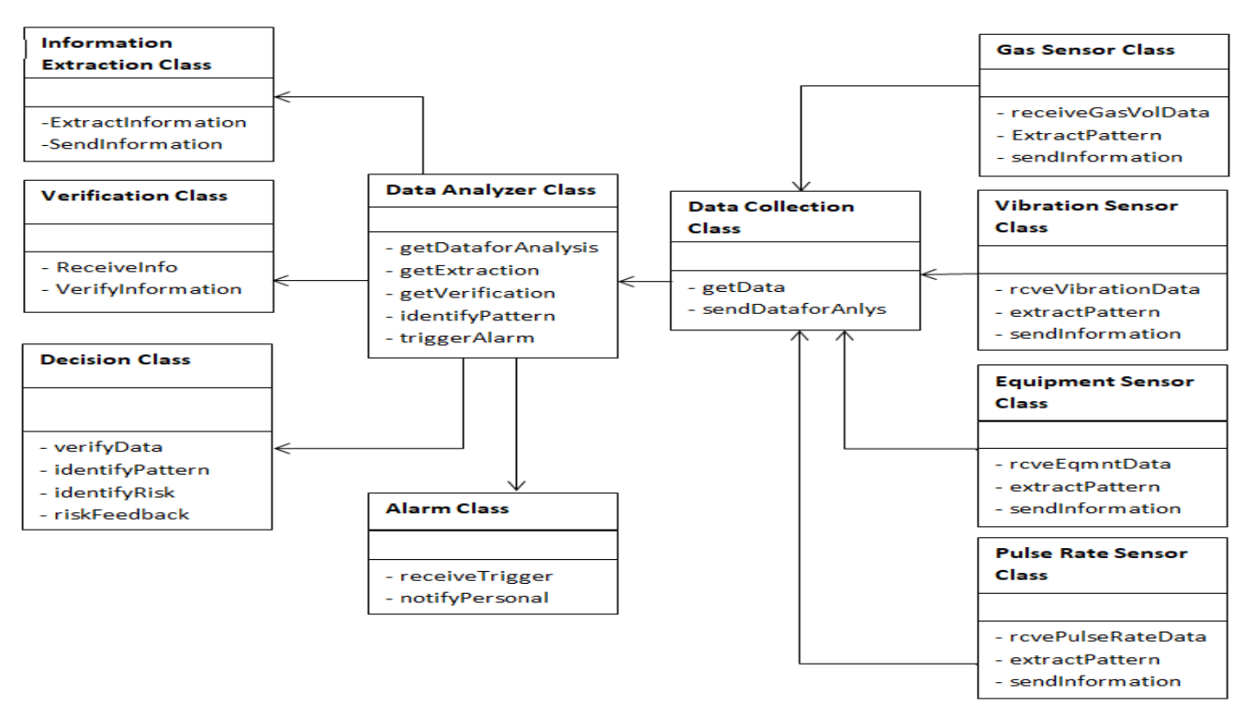**User Interface:**

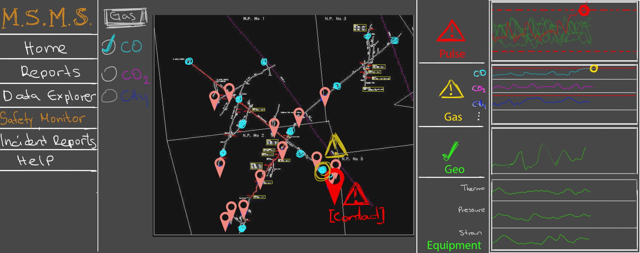

**Conclusion**

The​ ​project​ ​aims​ ​to​ ​improve​ ​the​ ​safety​ ​compliance​ ​of​ ​mining​ ​industries.​ ​Small​ ​scale mining​ ​industries​ ​occupy​ ​substantial​ ​portion​ ​of​ ​the​ ​overall​ ​mining​ ​industry.​ ​Safety​ ​compliance​ ​in such​ ​industries​ ​is​ ​often​ ​neglected.​ ​The​ ​project​ ​aims​ ​to​ ​build​ ​a​ ​product​ ​that​ ​would​ ​help​ ​improve the​ ​overall​ ​safety​ ​of​ ​mining​ ​industries​ ​in​ ​cost​ ​effective​ ​manner